Project Title: ATM FACILITATOR SOFTWARE FOR CHILDREN

Detail | Information
Submitted By | KUNWAR SINGH
Registration Number | 25BCE11021
Program | COMPUTER SCIENCE CORE
Course Code | CSE1021
Course Name | Introduction to problem solving and programming
Faculty | SANDEEP MONGA
Institution | Vellore Institute of Technology, Bhopal ¹⁰
Academic Year | 2025-29 ¹¹

ATM FACILITATOR SOFTWARE FOR CHILDREN — DETAILED DESCRIPTION.

THE MAIN MOTIVE IS TO CREATE A PROGRAM WITHOUT USING ANY LIBRARIES .
RATHER USING PROPER LOGIC OF PYTHON

1. Project Overview

This program simulates a simple ATM designed for children. It supports basic banking operations such as withdraw, deposit, and balance checking, and converts the resulting balance into words.
The program is intentionally kept simple, using only basic Python concepts—variables, conditionals, loops, dictionaries, and user input.

2. Starting Balance and Main Variables

I — The pre-coded initial balance (65986).

c — User’s menu choice:

'A' → Withdraw

'B' → Deposit

'K' → Check balance

'X' → Exit (in enhanced version)

r — Amount entered by user for withdrawal/deposit.

a — Updated balance after the operation.

b — String version of the balance, used for digit-to-word conversion.

l1 — List of digits in string form (e.g., "65986" → ['6','5','9','8','6']).

z — Final converted amount in words.

3. User Interaction & Flow

1. The program displays a menu with options A, B, K, X.

2. Based on user choice:

Withdraw (A):
User enters an amount. If the amount is less than the current balance, balance decreases. Otherwise, it prints "insufficient balance".

Deposit (B):
User enters an amount to deposit. Balance increases.

Check Balance (K):
Program shows the current balance (no change).

Exit (X):
Program stops.

3. After completing the transaction, the program converts the numeric balance into words.

4. The user is asked whether they want to continue using the ATM:

Do you want to use the ATM again? (Y/N):

5. If the user chooses Y, the program repeats. Otherwise, it exits.

4. Digit-to-Word Conversion Logic

The program converts numbers from 1 digit to 5 digits into English words using dictionaries:

Dictionaries used:

d → words for digits (one, two, three...).

d1 → words for tens (twenty, thirty...).

d3 → special words for 10–19 (ten, eleven...).

Conversion behavior:

1-digit numbers → direct lookup using d.

2-digit numbers starting with '1' → teen numbers using d3.

Other 2-digit numbers → combine tens (d1[first digit]) + ones (d[last digit]).

3-digit numbers →
"X hundred YZ"

4-digit numbers →
"X thousand Y hundred Z"

5-digit numbers →
"XY thousand Z hundred PQ"

Example:
65986 → "sixty five thousand nine hundred eighty six"

5. Limit for Children Account

If the final balance has 6 or more digits, the program prints:

CHILDREN ACCOUNT DO NOT ALLOW AMOUNT ABOVE 100000

No word conversion is performed in this case.

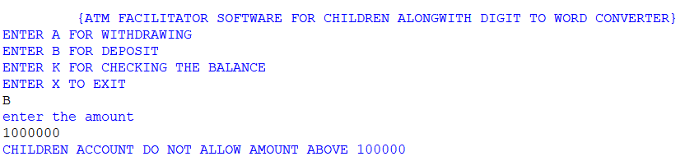

6. Error Handling

Non-numeric input for amounts → program shows an error and ignores the entry.

Invalid menu option → program prints “Invalid option selected. Showing balance.”

Zero-handling: zeros produce blank word segments, matching the original program’s style.

7. Loop Behavior

The program runs inside a while True loop.
After each transaction and word conversion, it asks:

Do you want to use the ATM again? (Y/N):

Entering:

Y / y → program repeats.
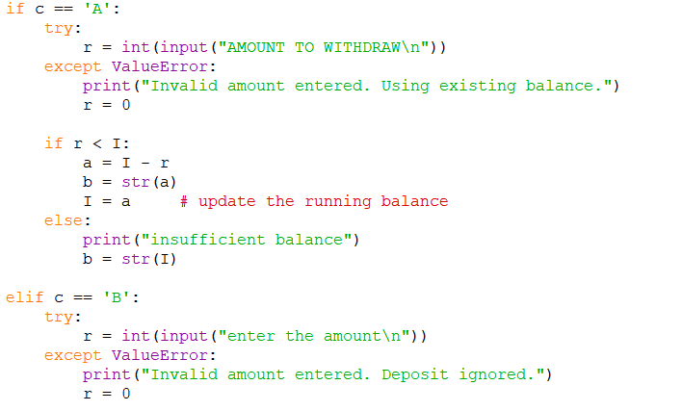
Any other input → exits with a thank-you message.

8. Why This Design? (Logic Reasoning)

Uses only simple Python, no advanced functions or external 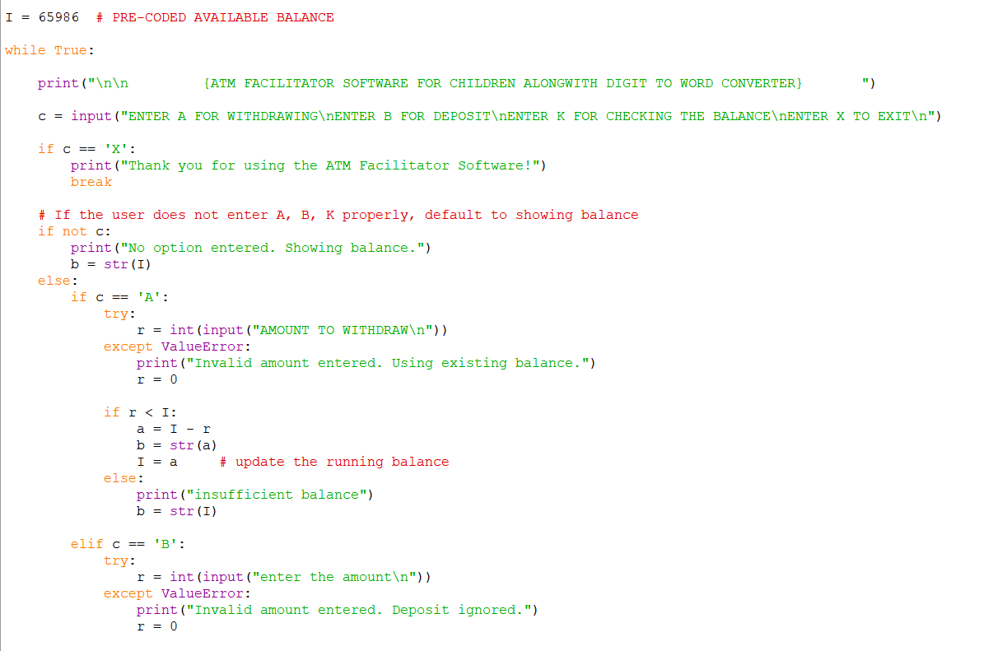

libraries. 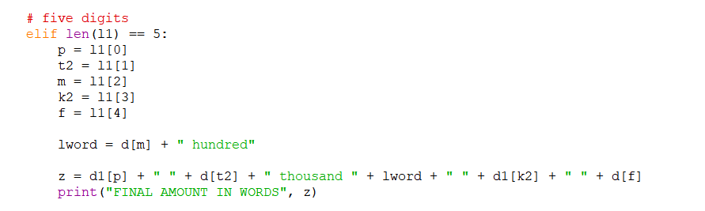

Maintains original logic and behavior from the initial program.

Easy for beginners to understand.

Provides educational exposure to:

Conditionals

Loops

Dictionaries

Error handling

String manipulation

9. Example Outputs

Input: Withdraw 100
Output words: “six five eight eight six” (depending on balance update) 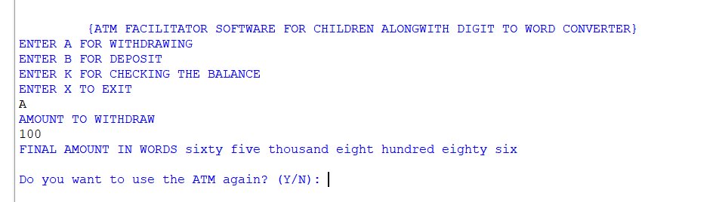

Output words: “seven zero nine eight six”

Input: Check Balance (K) → Shows words of current balance.

Input: Balance above 100000 → Shows the child account warning.

10. What Can Be Improved (Optional Enhancements)

Not implemented to keep original logic intact, but possible improvements:

Better spacing in word formatting.

Add support for numbers above 100000 (lakhs/crores).

Accept lowercase menu options.

Convert entire number 0 to "zero".

Cleaner dictionary lookup without nested loops.

11. Testing Checklist

Withdraw < balance → works

Withdraw > balance → "insufficient balance"

Deposit valid amount → updates balance

Invalid amount (letters) → error handled

Check balance → word conversion correct

Loop option works

Limit of 100000 works

12. Author Notes

This program is structured for beginner-level Python education and can be extended further as needed.

